122 cd Desktop/

123 mkdir Gittest

124 cd Gittest

125 git init

126 git status

127 git add .

128 git commit -m "test1 added"

129 git log

130 git remote add origin https://github.com/rajesh1999/Project_test.git

131 git remote -v

132 git push origin master

133 git branch

134 git branch develop

135 git status

136 git merge master

137 git status

138 git branch

139 git checkout master

140 git branch

141 git checkout develop

142 git merge master

143 git status

144 git add .

145 git push origin master

146 git log

147 git push origin develop

148 git checkout master

149 git add .

150 git commit -m "s remove "

151 git push origin master

152 git checkout develop

153 git add .

154 git commit -m "s added"

155 git push origin develop

156 git pull origin develop

157 git push origin develop

158 git add .

159 git commit -m "s added"

160 git push origin develop

161 git log

162 git checkout master

163 git log

164 git status

s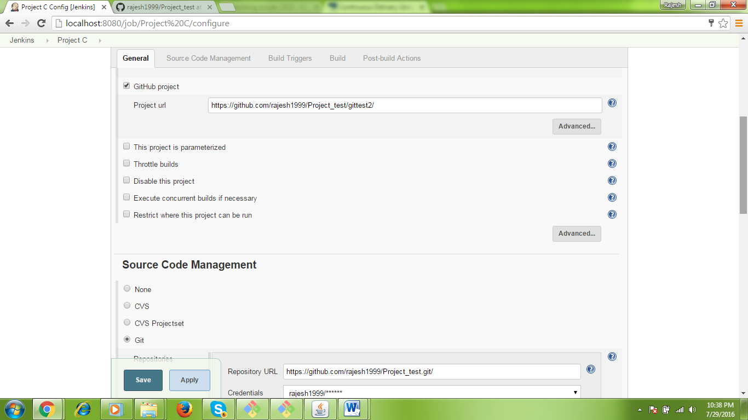

Here check the 2 things

1. GitHub Project Project URL.. <https://github.com/rajesh1999/Project_test/gittest2/>
2. Under SCM Git Repositories URL: <https://github.com/rajesh1999/Project_test.git/>